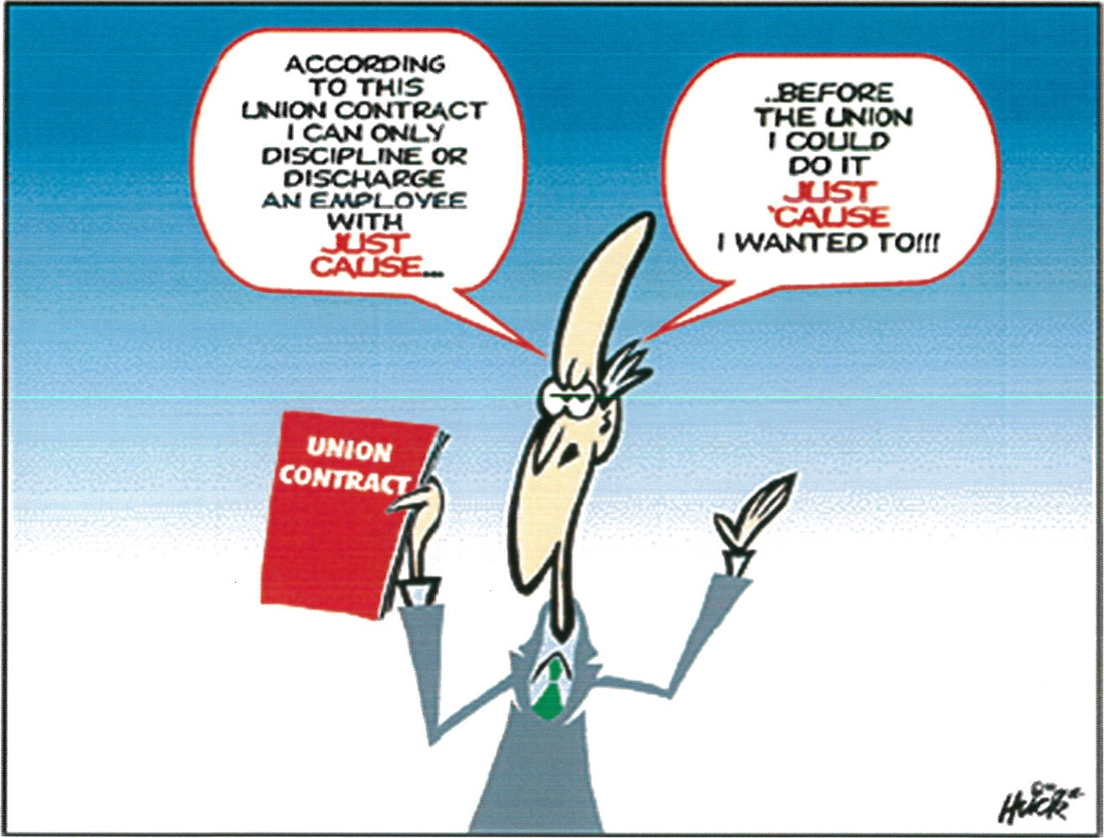
JUST CAUSE
- Our main contractual weapon in discipline and discharge cases is usually the requirement that the boss must have "just cause" (or "fair cause" or "proper cause") to take action against an employee. Even if these words are missing from the contract, many arbitrators use this standard, anyway.
- But, what is "just cause"? Simply put: it means the employer must have a reason (he or she must have "cause") for imposing discipline and the reason must be fair ("just").

